
SPECIFICATION
FOR APPROVAL
Part name：Din-Rail Terminal Block(RTB)H
Part No.：RTB404-08-01-2
Cust. P/N：
Date：2008-2-19

Seller Confirmation Customer Confirmation
Written by | Qiang.Zhou |  | Project Audit
Checked by | Shangyang.Yi |  | Structure Audit
Approved by | Jim |  | Security Certification
 |  |  | Quality Approval

Supplier : Hangzhou antron electronics Co., Ltd.
Address : No.639 , Deng yun Road , Hangzhou China
Tel : 0571-89902210
Fax : 0571-89908128
Postcode: 310011
E-mail : anqiao@263.net

Customer: Customer P/N:
Seller: Hangzhou antron electronics Co., Ltd. Part No: RTB404-08-01-2

Revision for RTB404-08-01-2
Item No | Edition | Part Revised | Date Revised
1 | A | put in file | 2008-2-19
2
3
4
5
6
7
8
9

1.TYPE：RTB404-08-01-2

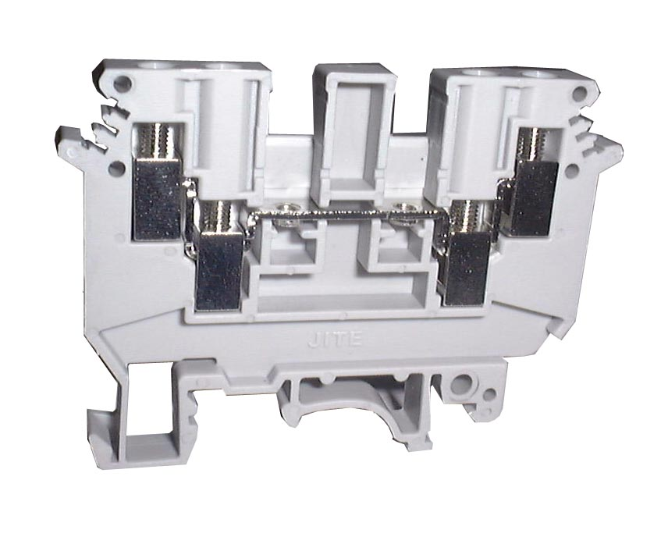

2.DRAWING&SIZES
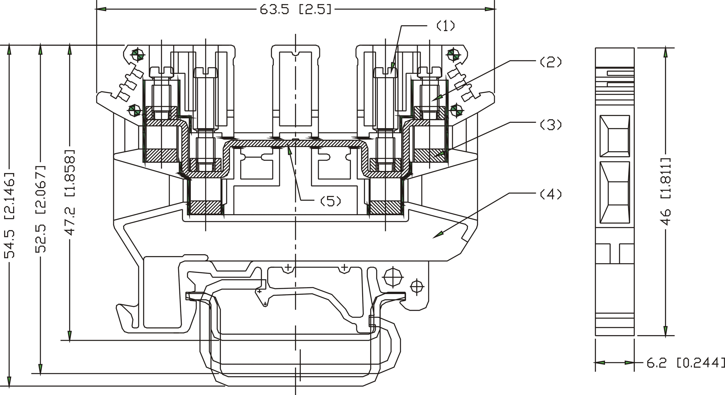
OVERALL SIZES
TOLERANCE：
＞120 | ±0.80
＞30～120 | ±0.50
＞6～30 | ±0.40
0～6 | ±0.25

3.BOM TABLE
ITEM. | PART NAME | MATERIAL | SURFACE OF CONTACT | QUANTITY(PCS)
(1) | L-SCREW | BRASS | Nickel Plated 5um | 2
(2) | S-SCREW | BRASS | Nickel Plated 5um | 2
(3) | BLOCK | BRASS | Nickel Plated 5um | 4
(4) | BODY | PA66 |  | 1
(5) | CONTACT | COPPER | Nickel Plated 5um | 1
4.TECHNICAL DATA:
WIRE RANGE： 12～24AWG
MAX. TORQUE： 4.4 L bf.in
ELECTRICAL RATING： 600V, 30A.
DIELECTRIC WITHSTAND： AC3000V, 1 minute
BREAKDOWN VOLTAGE: 8000V (1.2/50μs),
CROSS SECTION： 4mm²
STRIPPING LENGTH： 8mm
5.WORKING CONDITION：
OPERATING TEMPERATURE：-40℃～+105℃
ALTITUDE： Less than 2000m 40Kpa～80KPa
RELATIVE HUMIDITY： 5%～95%
POLLUTION DEGREE： Ⅲ
6.APPLICABLE STANDARDS
IEC 60947-1:2001 IEC 60947-7-1:2002 UL 1059:2001
7.ACCESSORIES
MOUNTING RAIL: JNS35:7.5/JNS35:15/JNS32
COVER: A070-0
SEPARATING PLATE： A060-0
MARKING STRIP: A061-10-5
STATOR： A047-0
8.PROCEDURE
Wires can be connected with this type of terminal blocks by a manua or automatic screwdriver.
9. PACKAGE
Tightly Sealed

