
SPECIFICATION
FOR APPROVAL
Part name：Din-Rail Terminal Block(RTB)H
Part No.：RTB425-03-01-9
Cust. P/N：
Date：2006-8-04

Seller Confirmation Customer Confirmation
Written by | Maker Liu |  | Project Audit
Checked by | Mac. He |  | Structure Audit
Approved by | Sun Li |  | Security Certification
 |  |  | Quality Approval

Supplier : Hangzhou antron electronics Co., Ltd.
Address : No.639 , Deng yun Road , Hangzhou China
Tel : 0571-89902210
Fax : 0571-89908128
Postcode: 310011
E-mail : anqiao@263.net

Customer: Customer P/N:
Seller: Hangzhou antron electronics Co., Ltd Part No: RTB425-03-01-9

Revision for RTB425-03-01-9
Item No | Edition | Part Revised | Date Revised
1 | A | put in file | 2006-8-04
2
3
4
5
6
7
8
9

1.TYPE：RTB425-03-01-9
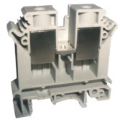

2.DRAWING&SIZES
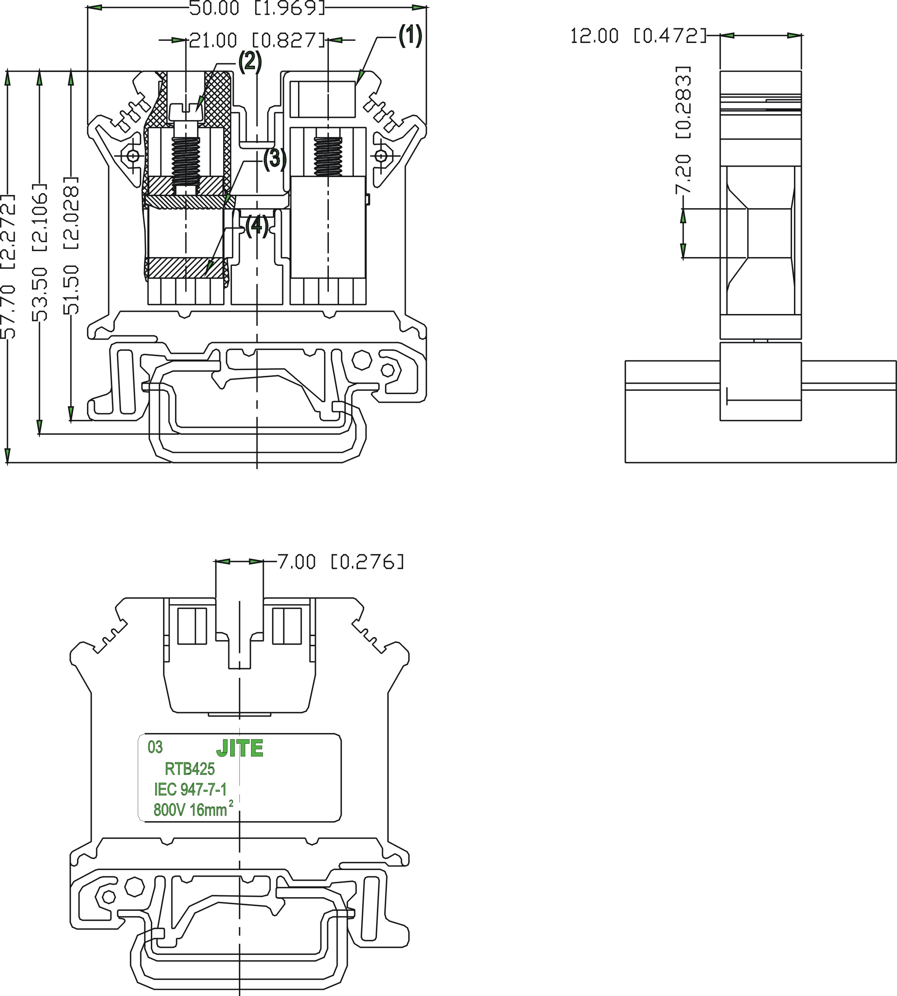

OVERALL SIZES
TOLERANCE：
＞120 | ±0.80
＞30～120 | ±0.50
＞6～30 | ±0.40
0～6 | ±0.25

3.BOM TABLE
ITEM. | PART NAME | MATERIAL | SURFACE OF CONTACT | QUANTITY(PCS)
(1) | HOUSING | PA66(UL94 V-0) |  | 1
(2) | SCREW | Brass H59 | Ni Plated 5um | 2
(3) | CONTACT | Brass H59 | Sn Plated 2um | 2
(4) | BLOCK | Brass H59 | Sn Plated 2um | 1
5.TECHNICAL DATA:
WIRE RANGE： 6～12AWG
MAX. TORQUE： 1.5 Nm
ELECTRICAL RATING： 800V, 101A.
DIELECTRIC WITHSTAND： AC3000V, 1 minute
BREAKDOWN VOLTAGE: 8000V (1.2/50μs),
CROSS SECTION： 25mm²
STRIPPING LENGTH： 11mm
6.WORKING CONDITION：
OPERATING TEMPERATURE：-40℃～+105℃
ALTITUDE： Less than 2000m 40Kpa～80KPa
RELATIVE HUMIDITY： 5%～95%
POLLUTION DEGREE： Ⅲ
7.APPLICABLE STANDARDS
IEC 60947-1:2001 IEC 60947-7-1:2002 UL 1059:2001
七.ACCESSORIES
MOUNTING RAIL: JNS35:7.5/JNS35:15/JNS32
END COVER: DG425-03

SEPARATING PLATE： A048-0
MARKING STRIP: A075-10-5
8.PROCEDURE
Wires can be connected with this type of terminal blocks by a manua or automatic screwdriver of M4.
9. PACKAGE
Tightly Sealed

